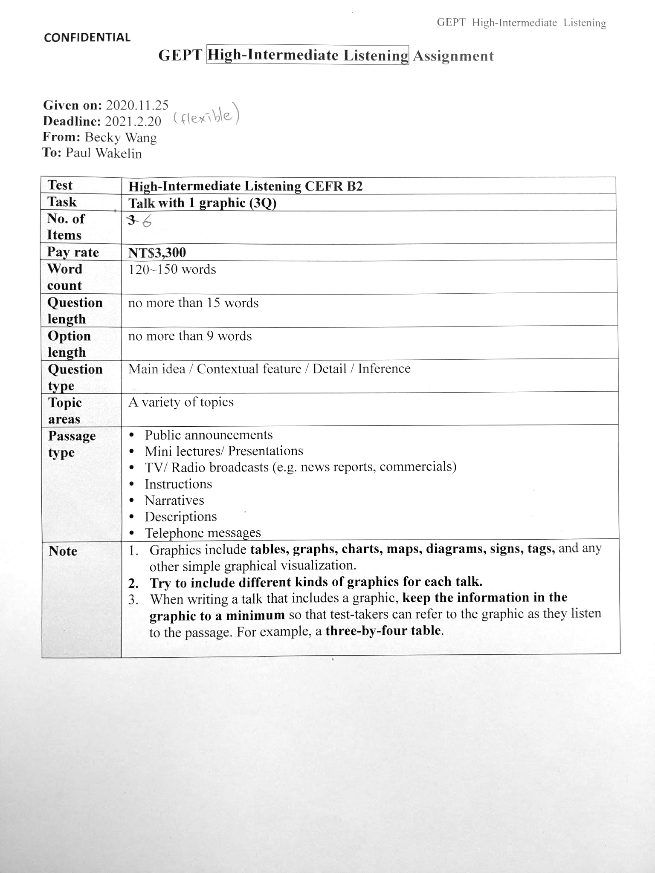

For software testing purposes:

Are the hyphenated words long-term, part-time, non-violent and make-up,

And short words, such as:

I’m, you’re, he’s, she’s, it’s, we’re, they’re, himself, to be, so, and, won’t, don’t, didn’t, did, shan’t, might, mightn’t, wouldn’t

and the interesting ma’am

Phrases such as Mother’s Day and New Year’s Eve won’t be recognized

and how about Mr. and Mrs.

and regularly formed adjs such as quickly in contrast to partly (which is actually hi-int)

# Item 1 - lecture

sources:

* [Veganism: Why are vegan diets on the rise?](https://www.bbc.com/news/business-44488051)
* [UK diet trends 2021](https://www.finder.com/uk/uk-diet-trends)
* <https://www.bbc.com/news/business-48141428>
* based, very loosely, on these figures:

| Meat | 84 |
| --- | --- |
| Pescatarian | 9 |
| Vegetarian | 6 |
| Vegan | 3 |
| lifestyle vegan | 2 |
|  | 100 |

(I realize i’ve shown the last 4 statistics as including each other, but the chart is impressionistic, so I think it is still gives a good-enough overview of the situation.)

**Figure 1**

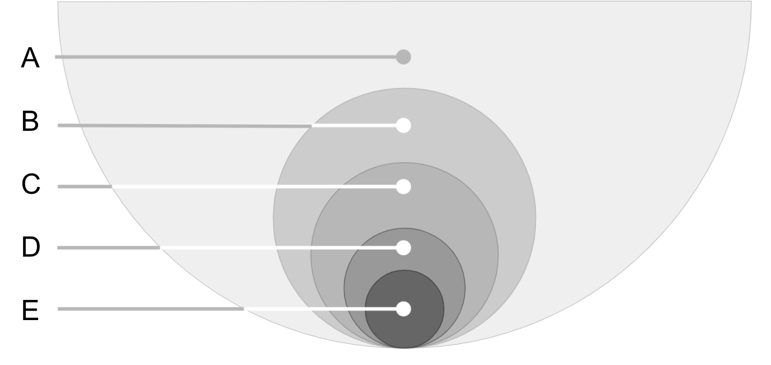

Wordcount 147

| | **Blah** | | --- | | cell | | cell | | Next, I’d like to show you the target of our new product line. As you can see from the slide, while the majority of our market still enjoys meat, there is a growing trend toward vegetarianism. Group B shows what are termed “pescatarians”; they only eat fish and seafood and represent almost one in ten consumers. From anecdotes, we know that even more consumers reject red meat but are happy to eat white meat such as chicken. However, we have no figures for that group, so they’re not shown here. Our next group are the traditional vegetarians.  But I’m interested in the last two groups. They are both vegans, which means they refuse to eat any animal products, so no eggs or dairy products. Which brings us to our target group: so-called “lifestyle vegans”. They strictly refuse ALL animal products, which means no leather goods, for example. |
| --- | --- | --- | --- | --- |
|  | |  | **Question 1** | | --- | --- | |  | Which of the groups shows people who don’t eat any meat but will eat cheese? | | A. | B | | B. | C | | C. | D | | D. | E |  |  | **Question 2** | | --- | --- | |  | One group was discussed which is not included in the chart. Where would it be? | | A. | Between A & B (key) | | B. | Between B & C | | C. | Between C & D | | D. | Between D & E |  |  | **Question 3** | | --- | --- | |  | The last group on the chart is likely to face severe restrictions in which range of products? | | A. | Alcohol | | B. | Shoes (key) | | C. | Spices | | D. | Furniture | |

# Item 2 - news report

**Sources**:

based on: [top 10 reasons people don`t give blood…](https://studylib.net/doc/6691224/top-10-reasons-people-don-t-give-blood%E2%80%A6): present as a bar graph

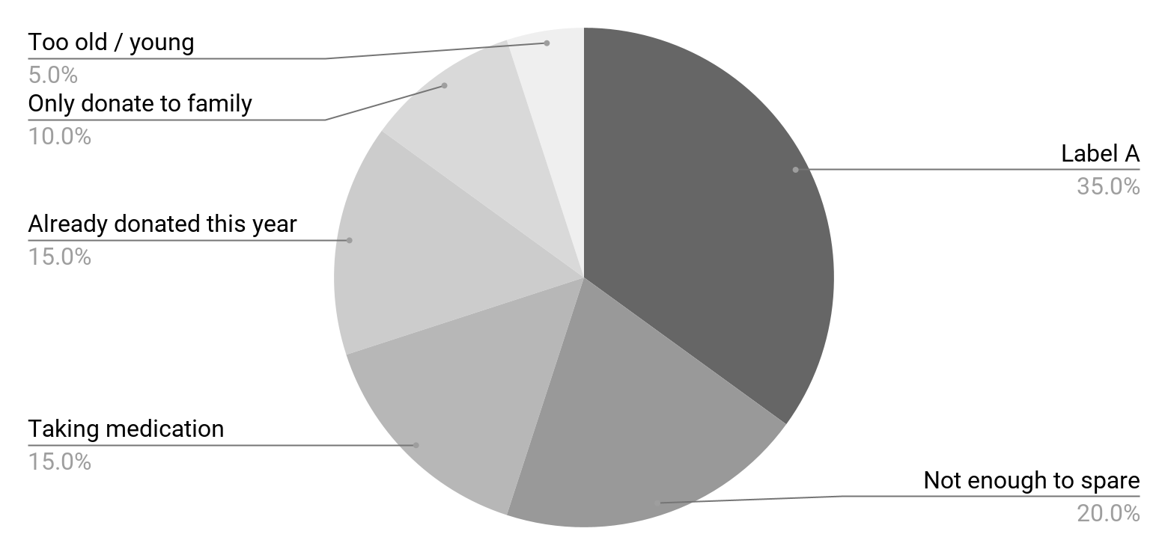

145 words

|  |  |
| --- | --- |
|  | In our next news item, the Health Minister has responded to the results of a nation-wide survey of blood donors. In a statement, the Minister sought to clear away myths about giving blood. She explained that anyone between the ages of 17 and 75 can donate not just once, but up to 6 times a year. She emphasized that the body of a healthy individual can make up the volume of blood lost within 24 hours, so there was no need to worry about serious after-effects. She also reassured the public that treatments prescribed for most chronic diseases did not affect blood donation, either. The Minister finished by addressing the main concern expressed in the report. She said that a fear of pain and surgical procedures, however minor, was perfectly natural. But she stressed that the benefit to the nation far outweighed any mild discomfort. |
|  | **Question 1**  What is the best title for this chart?   1. Justifications for withholding blood (key) 2. Key concerns of health professionals 3. Methods of increasing blood supplies 4. Ways to improve donation rates   OR  What prompted the Minister to make her announcement?   1. Research into public attitudes regarding health (key) 2. A widespread rejection of new safety measures. 3. Fears of a shortfall in blood donations this year 4. Reports from medical staff highlighting a problem   **Question 2**  According to the talk, what is the most likely text for Label A?   1. Hate needles (key) 2. Poor advertising 3. Too busy 4. Not a priority   **Question 3**  What is the speaker likely to discuss next?   1. The question of recipients (key) 2. Extending age eligibility 3. Reducing waiting lists 4. Setting the advertising budget |

# Item 3 - staff training talk

Sources:

* <https://www.cdc.gov/vaccines/pubs/pinkbook/vac-admin.html#:~:text=Talking%20with%20Parents%20about%20Vaccines%20for%20Infants>
* and the associated image:  
   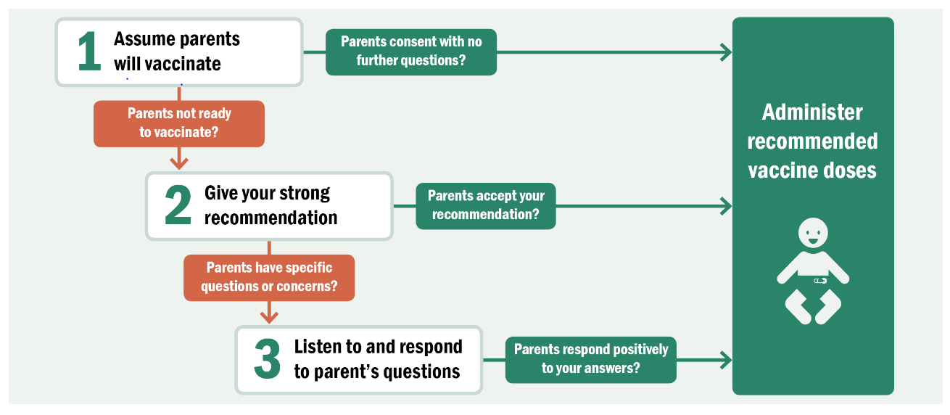
* artwork based on:  
  123rf [圖片編號 : 74714811](https://tw.123rf.com/photo_74714811_kids-and-vaccines-vaccination-children-.html?vti=nt0ta582nabehcmy40-1-19)  
  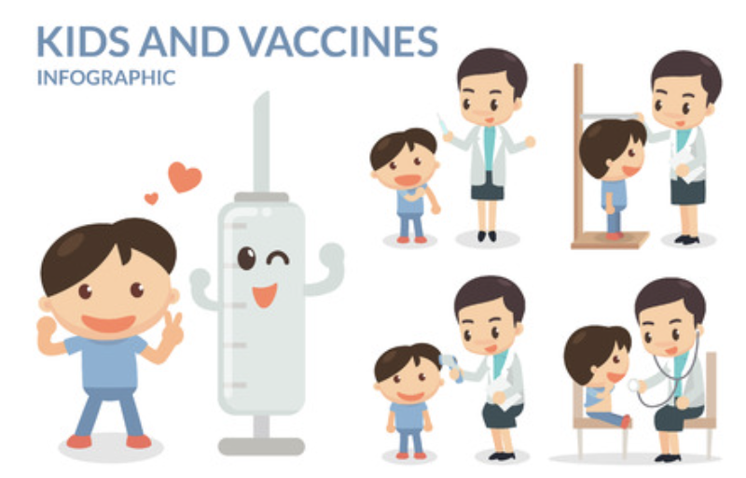
* My artwork:  
  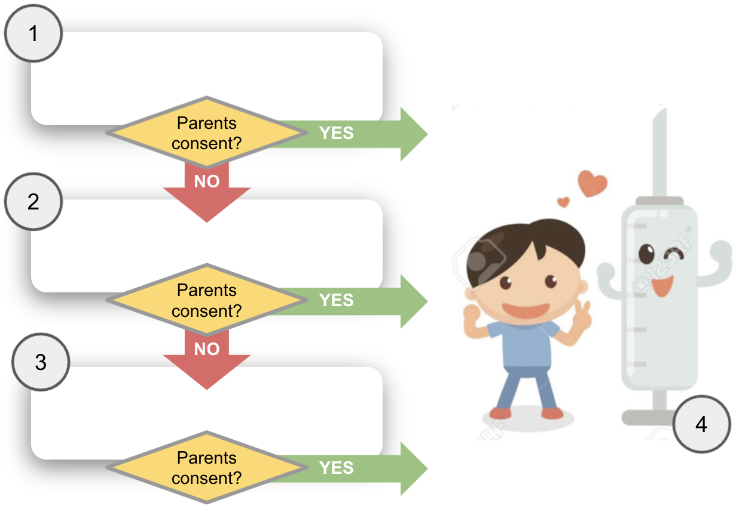

Wordcount: 145

As you know, getting a vaccine shot is one of the most important gifts that a parent can give their child. And research shows that parents regard YOU as their most trusted source of vaccine information. This, then, makes your interaction with parents key to ensuring children receive their recommended shots on schedule.

We’ve found that you can achieve the best results by starting off with so-called “presumptive language”. That is, rather than saying “What do you want to do about shots today?”, you say instead: “Your child needs two vaccines today.”

Many parents are naturally skeptical, so you should not feel offended if they question you. Answer all enquires politely and clearly. Use everyday language, but don’t talk down to them. At the end of the day, however, you must also accept that it is their right to deny their child a vaccine shot.



**Question 1**

Who is this talk aimed at?

1. Health professionals (ke
2. Parents with infants
3. Young people
4. Vaccine suppliers

Which of the steps in the flow-chart below illustrates where “presumptive language” should be used?

Step 1 (key)

Step 2

Step 3

Step 4

**Question 3**

How does the speaker end this section of the talk?

1. By accepting limitations (key)
2. By giving an example
3. By telling an anecdote
4. By hailing successes

# Item 4 - description

Sources:

* <https://www.wynnslocksmiths.com.au/how-keys-work/>
* <https://www.explainthatstuff.com/yalelock.html>
* artwork slightly adapted from [123rf.com](https://tw.123rf.com/photo_25250524_cutaway-pin-tumbler-lock-with-the-correct-key-inserted-the-lock-mechanism-that-uses-pins-of-varying-.html?vti=muhfyce7kegz4axys2-1-12)

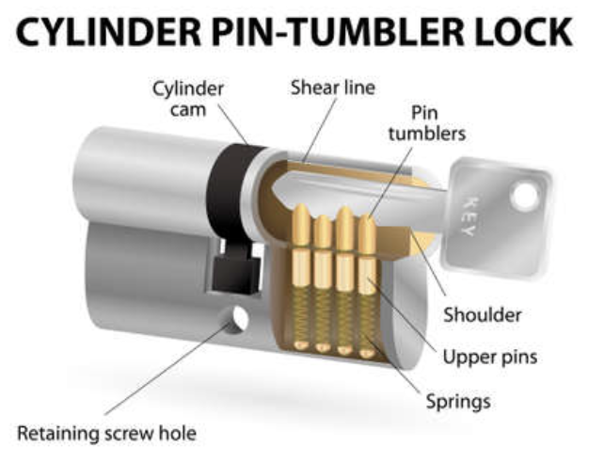

Wordcount 143

One of the most common types of lock is actually based on a principle first used by the Egyptians at the time the pyramids were being built. But while those first locks used wood, modern locks use metal. The mechanism remains the same, however. When the correct key is inserted, it enables a cylinder to turn, thus pulling back the bolt in the lock and opening it.

The key works by engaging with a series of pins, typically five or six, held in place by springs. The key is shaped to lift the pins until they are all level with the top of the cylinder. Once in a line, called the “shear line”, the cylinder is free turn. If the wrong key is inserted, its shape does not create a straight shear line. Consequently, the pins poke through the cylinder and block its movement.



(screenshot in case the included drawing is messed up during file transfer:)

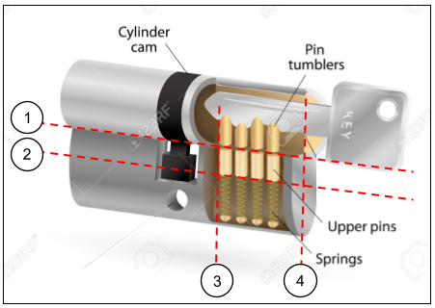

**Question 1**

Which line shows the “shear line” discussed in the talk?

1. Label 1 (key)
2. Label 2
3. Label 3
4. Label 4

**Question 2**

Which part of diagram has been simplified, according to the information in this talk?

1. The number of the pins (key)
2. The shape of the key /  
   The molding of the key
3. The mechanism of the springs
4. The position of the key shaft

**Question 3**

Which of these points about the design is made in the talk?

1. It has ancient origins. (key)
2. It is relatively secure.
3. It has a critical flaw.
4. It is rarely employed now.

# Item 5 - phone message

Source:

* [Basic Retail Floor Plans (Store Layouts)](https://www.thebalancesmb.com/types-of-store-layouts-2890503)
* [8 Retail Store Floor Plans: How to Find the Best Retail Store Layout](https://koronapos.com/blog/retail-store-floor-plans/)
* [What's the Importance of a Shop Floor Plan? | Dominion](https://www.dominionprint.com/whats-the-importance-of-a-shop-floor-plan/)

Wordcount: 145

Hey Tom! Judy here with some thoughts on the layout of your new high-street store. Your idea of a regular grid pattern is appropriate for supermarkets but not for the brand image you’re trying to convey. True, it utilizes space economically, but it can feel confined. By hiding customers from staff, it can prevent customers from quickly locating the products they want and even encourage theft! To overcome these problems, many retailers put displays at an angle, although that’s not so space-efficient.

But to be honest, I think the so-called “angular” floor plan is best for you. Its curves and free-flowing lines can focus on specific areas. It’s ideally suited to exclusive specialty stores with a low number of high-value products like yours. Because your store is fairly large, a mixture of patterns might be a possibility, too. Anyway, let’s discuss it on Monday. Bye!



(screenshot in case the included drawing is messed up during file transfer:)

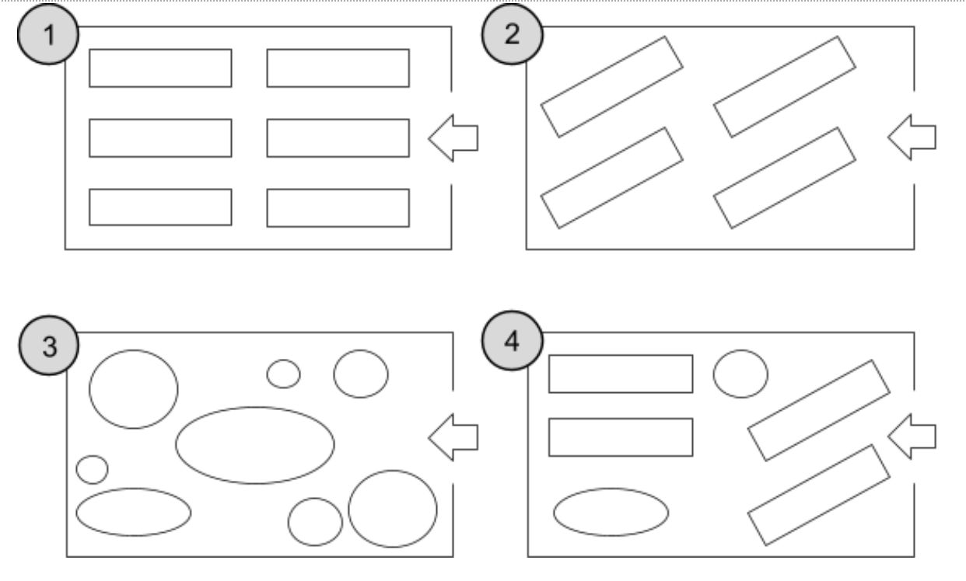

**Question 1**

Which of the following layouts does Judy recommend?

1. Layout 1
2. Layout 2
3. Layout 3 (key)
4. Layout 4

**Question 2**

Which of the layouts below has security implications?

1. Layout 1 (key)
2. Layout 2
3. Layout 3
4. Layout 4

OR

What disadvantage does Judy point out about layout 1?

1. Poor security (key)
2. Wastes space
3. Unpopular with retailers / Not flexible enough
4. Too complicated

**Question 3**

What is Tom’s new store likely to be selling?

1. Luxury goods (key)
2. Grocery items
3. Accessories
4. Artist’s supplies / Real estate

# Item 6 - advertisement

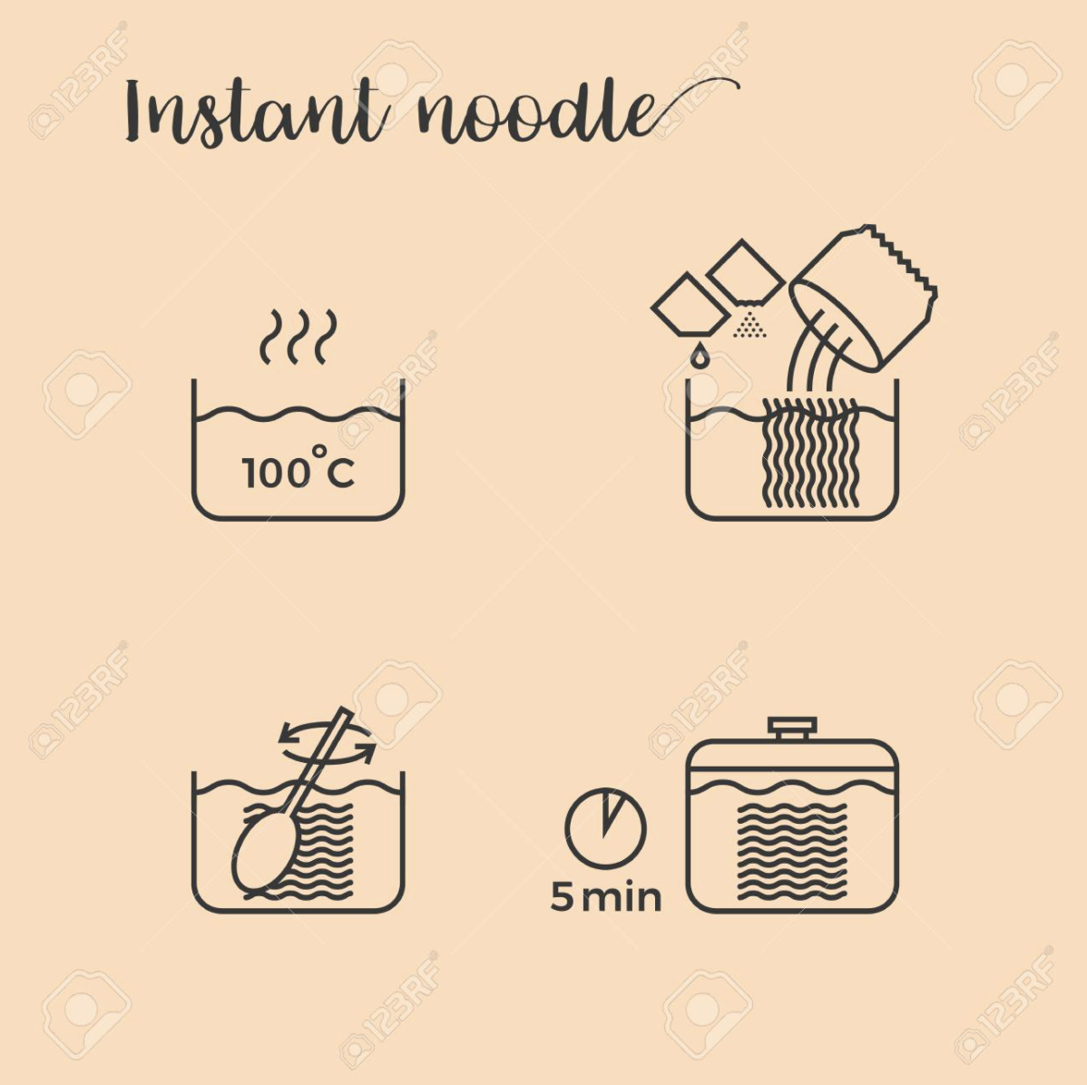

123RF: [圖片編號: 78526749](https://tw.123rf.com/photo_78526749_graphic-info-of-cooking-noodles-in-pot-step-by-step-outline-icon.html?vti=nsbetb0uei93iqp8v8-1-1)



(screenshot in case the included drawing is messed up during file transfer:)

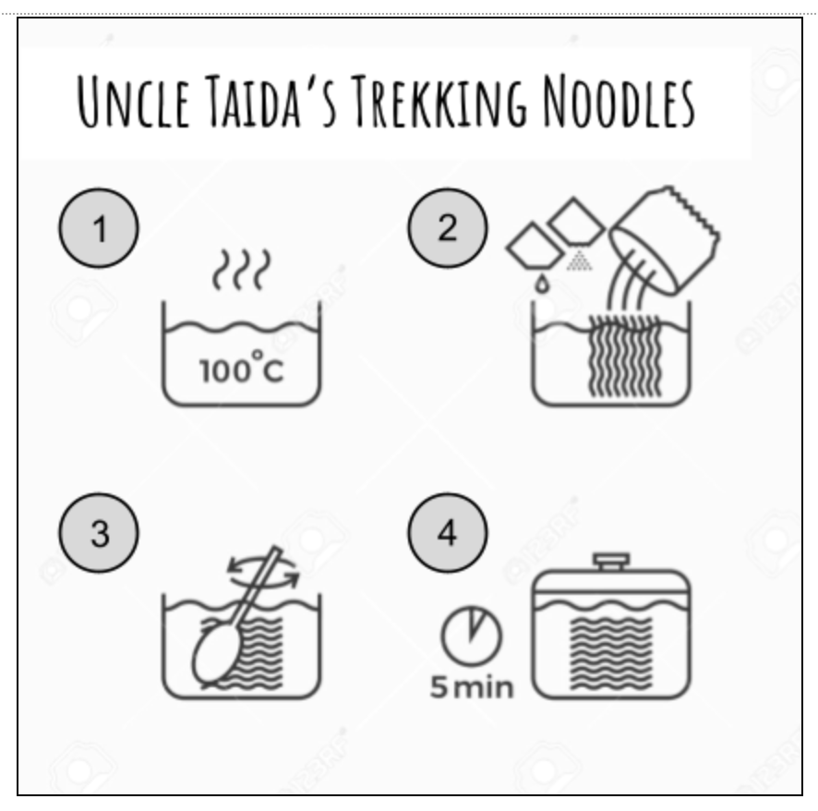

Wordcount: 142

Introducing Uncle Taida’s new “SUPER Trekking Noodles”!

After a long day of hiking, what could be better than a hot bowl of noodles? But what a pain: first having to heat your water till it boils; then waiting for the noodles to cool before you finally get to put them in your mouth! What a waste of time AND gas! There must be an easier way!

Because Uncle Taida loves a good hike as much as the next person, he decided to find out. Using only traditional ingredients but handling them according to a secret formula, he found a way to keep all the taste and texture of boiled noodles but at 30 degrees lower. That means they cook in half the time and they’re ready to eat straight after the 5 minute resting time.

Uncle Taida’s Trekking Noodles: the hiker’s friend!

**Question 1**

Which of the steps in the diagram is affected by in the new version of this product?

1. Step 1 (key)
2. Step 2
3. Step 3
4. Step 4

**Question 2**

What key element has been changed in this new product?

1. The preparation (key)
2. The ingredients
3. The packaging
4. The nutrients

OR

**Question 2**

What is one of the benefits of this new product?

1. Saves resources /   
   Adds convenience (key)
2. Increases portions
3. Reduces packaging
4. Improves flavor

**Question 3**

What marketing technique is used in this ad?

1. Identifying / Equating the company with the customer (key)
2. Advocating a transformation in behavior
3. Linking to a celebrity lifestyle
4. Appealing to basic economics